Converted PDF Document
Page 1
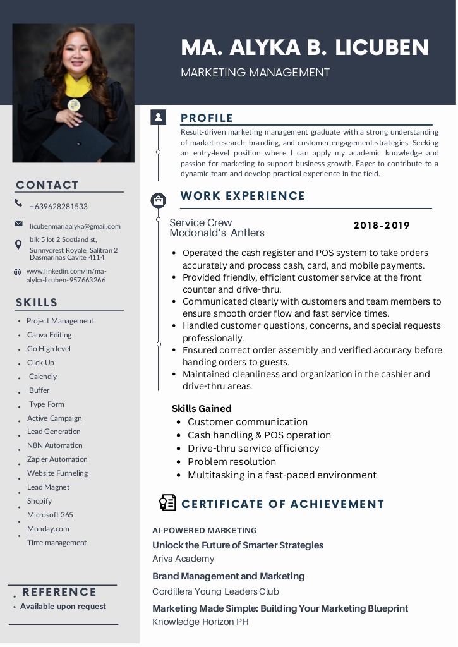
Editable text from this page:
CONTACT
% +629628281533
2 icubenmariaalyka@gmail com
DRS 2 Scotlond st,
Sunnycrest Royale, Salitran 2
Dasmarinas Cavite 4114
4 wwivilinkedin.com/in/ma:
alylalicuben-957663266
SKILLS
+ Project Management
+ Canva Editing
+ GoHigh level
+ Click Up
+ Calendly
+ Buffer
+ Type Form
«Active Campaign
Lead Generation
N8N Automation
Zapier Automation
Website Funneling
Lead Magnet
Shopify
Microsoft 365
Monday.com
‘Time management
. REFERENCE
+ Available upon request
MA. ALYKA B. LICUBEN
MARKETING MANAGEMENT
PROFILE
Result-driven marketing management graduate with a strong understanding.
of market research, branding, and customer engagement strategies. Seeking.
an entry-level position where | can apply my academic knowledge and
passion for marketing to support business growth, Eager to contribute to a
dynamic team and develop practical experience in the field
® WORK EXPERIENCE
Service Crew 2018-2019
Mcdonald’s Antlers
+ Operated the cash register and POS system to take orders
accurately and process cash, card, and mobile payments.
+ Provided friendly, efficient customer service at the front
counter and drive-thru.
+ Communicated clearly with customers and team members to
ensure smooth order flow and fast service times.
+ Handled customer questions, concerns, and special requests
professionally.
* Ensured correct order assembly and verified accuracy before
handing orders to guests.
* Maintained cleanliness and organization in the cashier and
drive-thru areas.
Skills Gained
* Customer communication
Cash handling & POS operation
Drive-thru service efficiency
Problem resolution
Multitasking in a fast-paced environment.
@2] CERTIFICATE OF ACHIEVEMENT
AL-POWERED MARKETING
Unlock the Future of Smarter Strategies
Ariva Academy
Brand Management and Marketing
Cordillera Young Leaders Club
Marketing Made Simple: Building Your Marketing Blueprint
Knowledge Horizon PH

Page 2
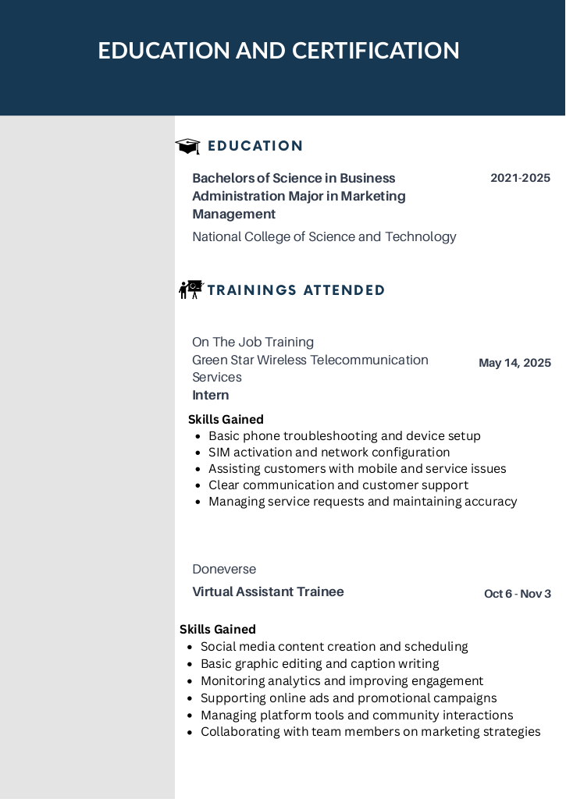
Editable text from this page:
EDUCATION AND CERTIFICATION
Wii EDUCATION
Bachelors of Science in Business 2021-2025
Administration Major in Marketing
Management
National College of Science and Technology
4B TRAININGS ATTENDED
On The Job Training
Green Star Wireless Telecommunication May 14, 2025
Services
Intern
Skills Gained
* Basic phone troubleshooting and device setup
* SIM activation and network configuration
* Assisting customers with mobile and service issues
* Clear communication and customer support
* Managing service requests and maintaining accuracy
Doneverse
Virtual Assistant Trainee Oct 6-Nov3
Skills Gained
* Social media content creation and scheduling
* Basic graphic editing and caption writing
* Monitoring analytics and improving engagement
* Supporting online ads and promotional campaigns
* Managing platform tools and community interactions
* Collaborating with team members on marketing strategies

